

Moving Forward on Data Infrastructure Technology Convergence

Proposed Expert Meeting: 28/29.10

at the Observatoire of Paris

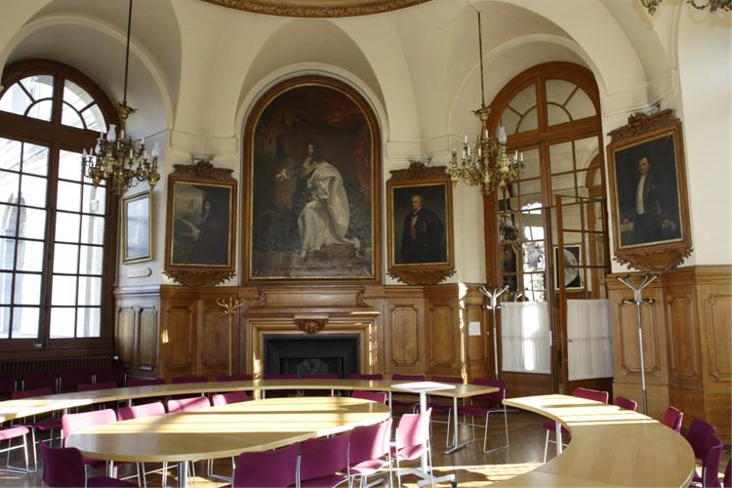

# Goal of the Meeting

The goal of the meeting is to decide about a widely agreed memorandom stating the requirements for FAIR Digital Objects and to agree on an organisational form to push the FAIR DO Agenda. The contributions and discussion should therefore take a constructive approach towards these goals.

# Tentative Agenda

### Day 1 - 28. 10. 2019

### 12.00 Reception and Coffee

### 13.00

Carlo Zwölf: Welcome

### 13.10 - 13.45 Session 1: Introduction to FAIR DO

Session Chair: Carlo Zwölf

* Peter Wittenburg: From Kahn Papers to RDA DFT DO Core Model
* Luiz Bonino: Extending the model to FAIR DO

Peter and Luiz will give a quick overview about the developments and motivations that led us to define the FAIR DO concept.

### 13.45 - 16.00 Session 2: Community Experts

Session Chair: Francoise Genova

We invited several speakers from active communities to present their needs and ideas.

* Dimitris Koureas: Infrastructure Challenges in Biodiversity and FAIR DO
* Tobias Weigel: Infrastructure Challenges in Climate Modelling and FAIR DO
* Barend Mons: Infrastructure Challenges in Biomedical and FAIR DO
* Koenraad de Smedt: Infrastructure Challenges in Language research and FAIR DO
* Massimo Cocco: Infrastructure Challenges in Environmental Research and FAIR DO
* Roberto di Cosmo: Infrastructure Challenges in Software Development and FAIR DO
* open discussion

Each speaker has 15 minutes to briefly describe the main challenges when building data infrastructures and to explain whether the concept of FAIR DO can be of help to solve major data infrastructure problems. We ask all speakers to present just 3 slides to address three questions:

* Which are the major challenges in your infrastructure building efforts?
* How would the FAIR DO concept help you to overcome essential challenges?
* Which requirements do you see which are currently not addressed by the FAIR DO concept?

### 16.00 - 16.30 Coffee Break (could also be done within the previous session

### 16.30 - 18.00 Session 3: Requirement Specifications

Session Chair: Bob Hanish

This session is meant to present the requirements specification so far and see where they need to be expanded based on the requirements addressed by the scientific community speakers and the evolving FAIR Maturity Indicators. Keith will present the FAIR Maturity Indicators and Larry will go through the requirements and indicate in how far they meet the Indicators. Both will take 20 minutes each to have time for discussions.

* Keith Russel: RDA FAIR Maturity Indicators
* Larry Lannom: Presentation of the Requirements so far and their matching with the indicators
* Open Discussion about possible changes of the Requirements

### 19.30 Joint Dinner

### Day 2 - 28. 10. 2019

### 9.00 -10.00 Session 4: Short Comments from Technologists on the Requirements

The requirements presented so far are backed up by many discussions in CNRI, RDA, DONA, GOFAIR, GEDE etc. and many experts have been involved. In addition, first implementations of components have been developed and the Linked Data Community has mechanisms in place. However, we also know that much more needs to be done to come to a fully functioning FAIR DO landscape ready for machine processing. Therefore, we invited some experts from different background to make short statements on the requirements and what is missing based on their broad experience. Mentioning 3 key points should be sufficient.

Session Chair: Erik Schultes

* Christophe Blanchi
* Jonathan Clark
* Ray Plante
* Tian Ye
* Klaas Wieringa
* Mark Wilkinson

### 10.00 - 10.30 Coffee Break

### 10.30 - 11.45 Session 5: Comments on Memorandum and Organisational Form

Session Chair: Jean Francois Abramatic

Barend and Robert Q. will open the session by presenting their views on the Memorandum to be presented to the outside world and for possible organisational forms to push the FAIR DO agenda. Each will take 15 minutes. Afterwards we will have short contributions from some experts who look from a more external point of view and an open discussion. Also here it would be good to have 3 key points being raised by the colleagues.

* Barend Mons: Memorandum on FAIR DO
* Robert Quick: Possible Organisational Forms

Commmenters

* Edit Herczog
* Bonnie Carrol
* Mark Leggott
* Beth Plale
* Michel Schoupe

### 11.45 - 13.00 Session 6: Conclusions

Session Chair: George Strawn

George will summarise his impressions about the meeting so far and describe the rough consensus that has been achieved on the requirements to be formulated in a memorandum and directions with respect to the organisational form. One or two Working Group(s) will be formed that will further work on these topics.

George statements will be followed by an open discussion about the tasks of these WG(s).

## Organisers

Edit Herzcog (RDA), Barend Mons (CODATA), Larry Lannom (CNRI), Robert Quick (IU), George Strawn (BRDI), Peter Wittenburg (GEDE), Carlo Zwölf (VAMDC, GEDE)